Name: Cargile, Christopher
Student access ID: 10059306
Project: JEdit
Change Number: 2
Date: 11/12/2013
Team Number: 2

“Edit Remote Files”

- Change Request:
The intention of the change requested is to implement a file FTP push/download utility for files (or temp files in the case of a not-yet-saved buffer, presumably). Since access-control permissions would be necessary to upload/download from most FTP sites, the dialog will allow for this as well as the URL of the file to be stored/retrieved at/from, where overwrite is the default behavior when necessary. As either HTTP or FTP should be supported, but not necessarily both, we chose FTP (store/retrieve vs. get/put – FTP vs. HTTP, I think).

- Concept Location:
JRipples’ GREP analysis using the text query ‘Buffer’ presented a substantial number of classes containing matches. jEdit being the main class was chosen as a likely location to start, as it initializes the program and contains some methods that seem helpful/relevant (newFile(), loadFile(), etc):

Table 1. Classes visited during concept location.
# | File name | Tool used | Located? | Comments
1 | jEdit.java | Manual Exploration/JRipples GREP | No; jEdit is not to change | Unchanged; jEdit contains called methods for CR#2
2 | Buffer.java | JRipples GREP | No, Buffer is not to change | Unchanged; Buffer does not contain methods called or changed
3 | VFSFileChooser.java | JRipples GREP (matching) but Eclipse JAVA Search used moreso | No, <- will not change. | Unchanged; VFSFileChooser seemed likely as cousin-candidate for FTPFileChooser but will not be necessary
4 | Actions.xml | Past Experience | Yes; CR will affect this file | Changed; CR#2 will require changing this file.
5 | jEdit_gui.props | Past Experience | Yes; CR will affect this file | Changed; CR#2 will require changing this file

- Impact Analysis:
]
Part of the difficult implementing FTP remote editing/save capability stems not only from comprehending and implementing JEdit’s unique implementation of the Swing GUI-API, but also from tying it into a previously not-understood Buffer/View management system. A future area for work in the CR #2 regard, might involve implementing an FTP-FS module with associated helper classes (ie: FTPFile,FTPFileFilter,FTPFileManager…)

Table 2. Classes visited during impact analysis.
# | Class name | Tool used | Impacted? | Comments
1 | BufferInsertRequest.java | JRipples GREP search | No; | Unchanged; tho this class is interesting because it is delegated to handle IO on buffers
2 | VFSFileChooserDialog | JRipples GREP/Eclipse JAVA Search | Yes; | Unchanged; this class is not directly changed but its behaviours mirrored to extend EnhancedDialog instance
3 | VFS.java | Eclipse JAVA Search/ JRipples GREP | No; | Unchanged; this class interacts with local FS which CR#2 may utilize but NOT as part of remote-file capability

- Learning process:.
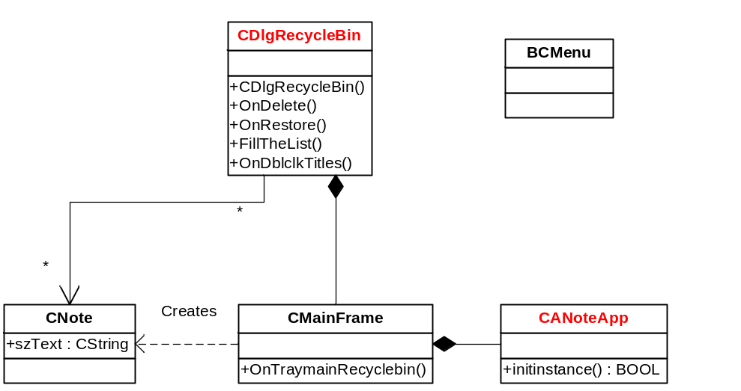
Figure 1 CR#2 class diagram

